

|  |  |  |  |  |  |  |  |  |
| --- | --- | --- | --- | --- | --- | --- | --- | --- |
|  | | | | | | | | |
|  | | Group Database Design Project | | | | |  | |
|  |  | | | | | | |  |
|  | | | | See the source image |  | | | |
|  | | | |  |  | | | |
|  | | | | October 2nd, 2021—SM 6205 Database Management—Dr. Alfred Castillo —  Group Four |  | | | |
|  | | |  | | |  | | |

##### Team Composition:

1. [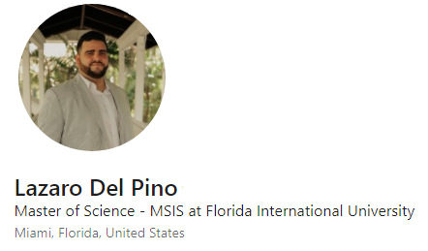](https://www.linkedin.com/in/lazarodelpino/)
2. [](https://www.linkedin.com/in/osahon2020/)
3. [](https://www.linkedin.com/in/jose-ramos-20142a6/)